Indian Center 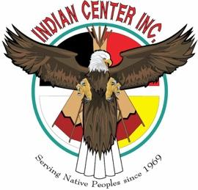
Our mission is to provide cultural and educational opportunity for the American Indian people of the Great Plains.

Job Title: Administrative Coordinator
Reports To: Executive Director
Position Summary: Provide coordination and support for the organization.
Job Duties:
- Provide administrative support for Leadership members, including providing daily support to the Executive Director to assure a seamless schedule of meetings and organization events. Represent the Indian Center as needed at both internal and community-based meetings and facility events.
- Maintain the primary organization calendar serving as the lead on coordinating all events and meetings for the organization and facility. Assure events/mtgs. are posted on social media/website/ lobby and with other community entities that share info (Cause Collective, NAM, etc.). Rescheduling events and meetings as needed to adhere to Indian Center policy with regards to funeral, wakes, memorials, and ceremonies.
- Data collection, filing, digitizing, and cataloging invoices and other important documentation. Collecting and inputting invoices, receipts, etc. into the drive and disturbing needed information to the appropriate personnel.
- Maintaining the Executive and personal office space for public interaction and to meet work requirements.
- Assist Development efforts by assisting with fund raising data collection, sending timely donor correspondence (Thank You’s, Invitations etc.) and other duties related to special donor events.
- Responsible for tracking key timelines, deadlines, and other scheduling needs. Communicate and gather all necessary info from appropriate staff to meet all requirements.
- Performs other duties as assigned.
Skills/Abilities Necessary
- Excellent organizational and communication skills (Experience with Google Drive, Docs, Excel, or equivalent programs)
- Excellent time management
- Adept at planning and maintaining a schedule
- Performs job tasks with integrity, confidentiality and with passion for the mission of the Indian Center
- Can easily commit to timeliness, and flexibility as needed to meet organizations needs as they change.
- Is comfortable with public interaction and conducting themselves in a respectful manner with the Native Community and other cultures.
- Supports the vision, mission and future of the organization is all ways possible.

